ITOPF Environmental Award won by ‘oil-free’ propeller shaft

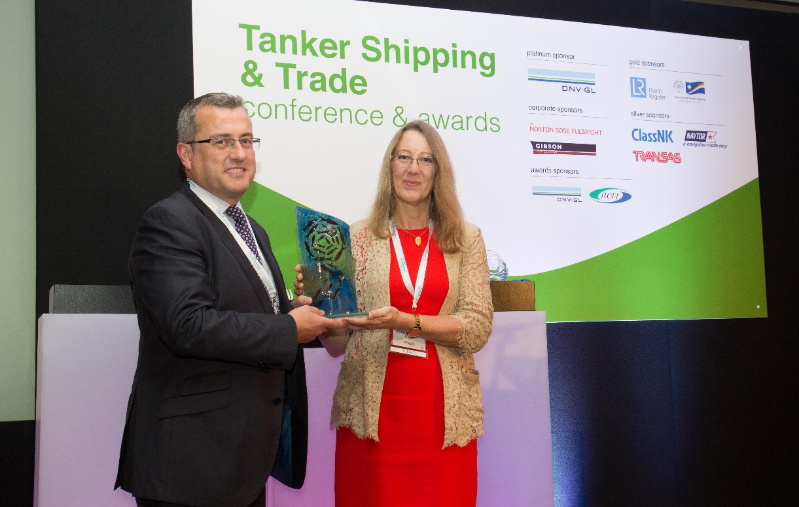
Dr Karen Purnell presenting the award to George Morrison of Thordon Bearings Inc
(photo courtesy of Tanker Shipping & Trade)

The first Environmental Award to be presented at the Riviera Maritime Media’s Tanker Shipping & Trade Conference was sponsored by ITOPF and awarded to Thordon Bearings Inc. for its COMPAC system. Dr Karen Purnell presented the award to George Morrison, Thordon Bearings’ Regional Manager West Europe and Africa, at the awards ceremony on 19th November, rounding off the two day Tanker Shipping and Trade Conference & Awards.
COMPAC, a seawater lubricated propeller shaft bearing system, prevents the seepage of millions of litres of oil into the world's oceans and reduces ship operating costs associated with aft seals and lubricating oil.
Dr Karen Purnell who sat on the award judging panel, alongside representatives from INTERTANKO, IACS, UK MCA and Scorpio Tankers, said "It is a challenge to identify opportunities that assist shipowners in meeting environmental standards cost-effectively and that don't end up creating new environmental problems. The COMPAC system meets this challenge and it is for that reason - and the system's simplicity - that we were able to present Thordon Bearings with the award."
Other award recipients included ITOPF's Chairman and CEO of Euronav, Paddy Rodgers, who won the Industry Leader Award.
After the awards ceremony, the entire gathering mingled at a celebratory reception sponsored by ITOPF.
26th November 2015

Notes for Editors:
1. The International Tanker Owners Pollution Federation Limited (ITOPF) was established as a non-profit making service organisation in 1968. In the early days its principal function was the administration of the TOVALOP voluntary oil spill compensation agreement. However, for the past 45 years ITOPF has also provided a broad range of technical services in the field of marine pollution to and on behalf of shipowners, their P&I insurers and other groups such as the International Oil Pollution Compensation Funds, as well as to the community at large.

2. ITOPF's Membership currently comprises some 7,000 owners and bareboat charterers of approximately 12,000 tank vessels with a total gross tonnage of about 370 million GT. The organisation also benefits from the participation of 721 million GT of non-tanker tonnage owned and operated by its Associates.

3. ITOPF's priority service is responding to accidental marine spills and the organisation's team of highly experienced technical staff are at constant readiness to travel anywhere in the world at a few hours’ notice. Since 1978 ITOPF staff have attended on-site at over 750 incidents around the world, giving the organisation unparalleled practical experience of the realities of combating major marine spills. ITOPF also:

- assesses the damage caused by spills to the environment and economic resources;
- provides advice on the technical merits of claims for compensation;
- conducts contingency planning, advisory and training assignments;
- produces a wide range of technical publications; and
- maintains various databases as well as a website at http://www.itopf.com

4. For further information contact:

Dr Karen Purnell (Managing Director)
Mrs Deborah McKendrick (Information Officer)
The International Tanker Owners Pollution Federation Limited (ITOPF)
1 Oliver’s Yard, 55 City Road, London EC1Y 1HQ

Tel: +44 (0)20 7566 6999
Fax: +44 (0)20 7566 6950
Email: deborahmckendrick@itopf.com
Web: www.itopf.com

